| **VISVESVARAYA TECHNOLOGICAL UNIVERSITY**  **“JnanaSangama”, Belgaum -590014, Karnataka.**    **LAB RECORD**  **Bio Inspired Systems (23CS5BSBIS)**  ***Submitted by***  **Shuvam Rajbanshi(1BM22CS275)**  ***in partial fulfillment for the award of the degree of***  **BACHELOR OF ENGINEERING**  ***in***  **COMPUTER SCIENCE AND ENGINEERING**    **B.M.S. COLLEGE OF ENGINEERING**  **(Autonomous Institution under VTU)**  **BENGALURU-560019**  **Sep-2024 to Jan-2025** |
| --- |

**B.M.S. College of Engineering,**

**Bull Temple Road, Bangalore 560019**

(Affiliated To Visvesvaraya Technological University, Belgaum)

**Department of Computer Science and Engineering**



**CERTIFICATE**

This is to certify that the Lab work entitled “ Bio Inspired Systems (23CS5BSBIS)” carried out by **Shuvam Rajbanshi(1BM22CS275),** who is bonafide student of **B.M.S. College of Engineering.** It is in partial fulfillment for the award of **Bachelor of Engineering in Computer Science and Engineering** of the Visvesvaraya Technological University, Belgaum. The Lab report has been approved as it satisfies the academic requirements of the above mentioned subject and the work prescribed for the said degree.

| Spoorthi D M  Assistant Professor  Department of CSE, BMSCE | Dr. Joythi S Nayak  Professor & HOD  Department of CSE, BMSCE |
| --- | --- |

**Index**

| **Sl.**  **No.** | **Date** | **Experiment Title** | **Page No.** |
| --- | --- | --- | --- |
| 1 | 3/10/24 | Genetic Algorithm | 1-4 |
| 2 | 24/10/24 | Particle Swarm Optimization | 5-9 |
| 3 | 7/11/24 | Ant Colony Optimization | 10-14 |
| 4 | 14/11/24 | Cuckoo Search | 15-19 |
| 5 | 21/11/24 | Grey Wolf Optimization | 20-24 |
| 6 | 28/11/24 | Parallel Cellular Algorithm | 25-28 |
| 7 | 5/12/24 | Optimization Via Gene Expression Algorithm | 29-33 |

Github Link:<https://github.com/Shuvam00/BIS-LAB/upload>

**Program 1**

**Genetic Algorithm for Optimization Problems.**

Implement a Genetic Algorithm using Python to solve a basic optimization problem, such as finding the maximum value of a mathematical function.

Algorithm:

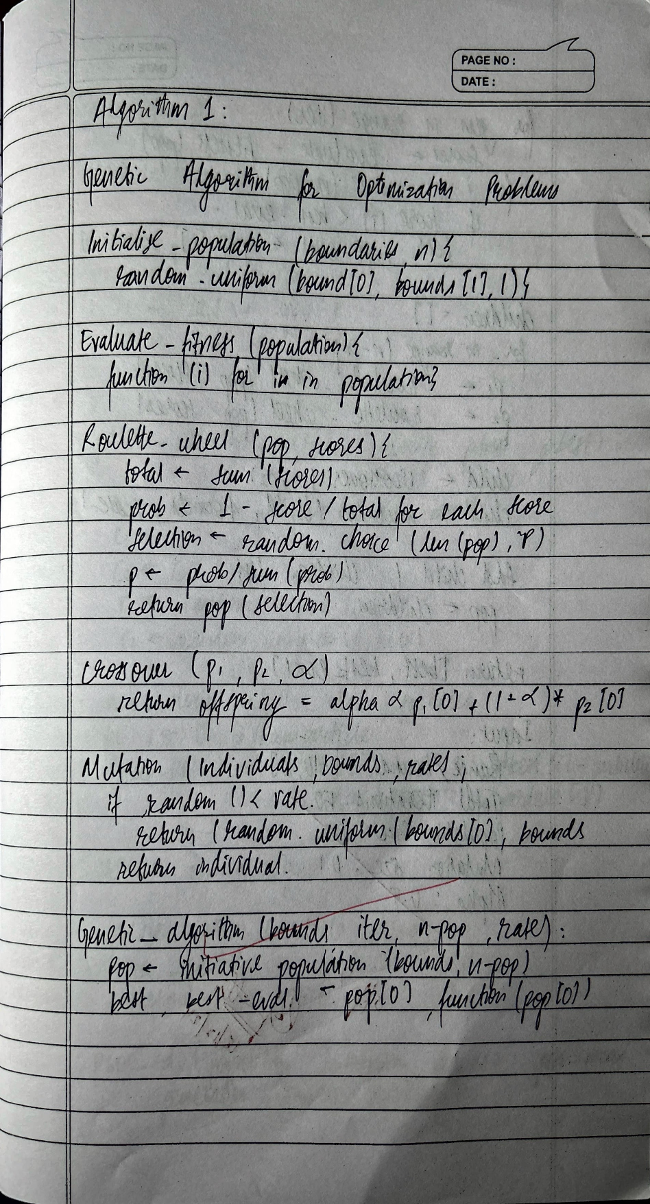

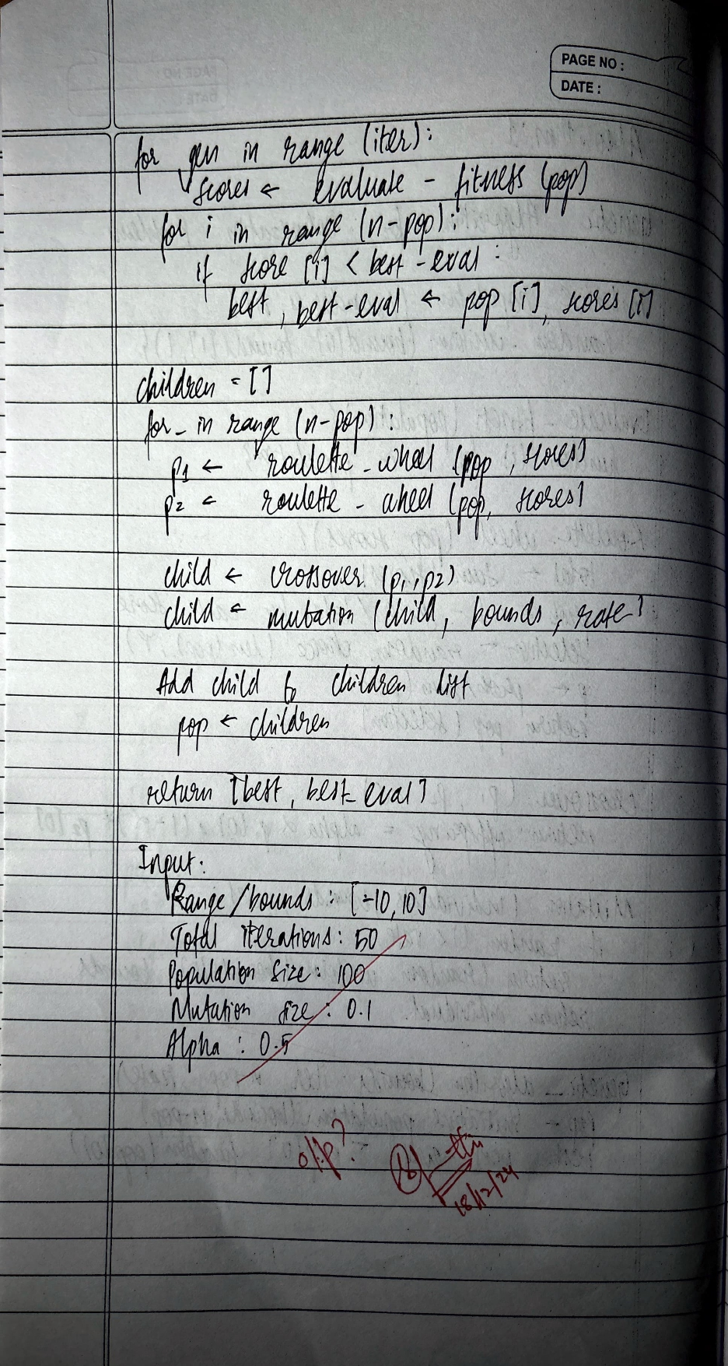

**CODE**:

import random

# Define the fitness function

def fitness_function(x):

return x**2 # Example function: f(x) = x^2

# Generate initial population

def generate_population(size, x_min, x_max):

return [random.uniform(x_min, x_max) for _ in range(size)]

# Selection process

def select_parents(population, fitnesses):

total_fitness = sum(fitnesses)

selection_probs = [f / total_fitness for f in fitnesses]

parents = random.choices(population, weights=selection_probs, k=2)

return parents

# Crossover process

def crossover(parent1, parent2):

alpha = random.random()

child = alpha * parent1 + (1 - alpha) * parent2

return child

# Mutation process

def mutate(child, mutation_rate, x_min, x_max):

if random.random() < mutation_rate:

child = random.uniform(x_min, x_max)

return child

# Genetic Algorithm

def genetic_algorithm(pop_size, generations, mutation_rate, x_min, x_max):

population = generate_population(pop_size, x_min, x_max)

for generation in range(generations):

fitnesses = [fitness_function(ind) for ind in population]

new_population = []

for _ in range(pop_size):

parent1, parent2 = select_parents(population, fitnesses)

child = crossover(parent1, parent2)

child = mutate(child, mutation_rate, x_min, x_max)

new_population.append(child)

population = new_population

best_solution = max(population, key=fitness_function)

return best_solution

# User inputs

pop_size = int(input("Enter population size: "))

generations = int(input("Enter number of generations: "))

mutation_rate = float(input("Enter mutation rate (0-1): "))

x_min = float(input("Enter minimum value of x: "))

x_max = float(input("Enter maximum value of x: "))

# Run the genetic algorithm

best_solution = genetic_algorithm(pop_size, generations, mutation_rate, x_min, x_max)

print(f"The best solution found is: {best_solution} with fitness value: {fitness_function(best_solution)}")

**Program 2**

**Particle Swarm Optimization for Function Optimization.**

Implement the PSO algorithm using Python to optimize a mathematical function.

Algorithm:

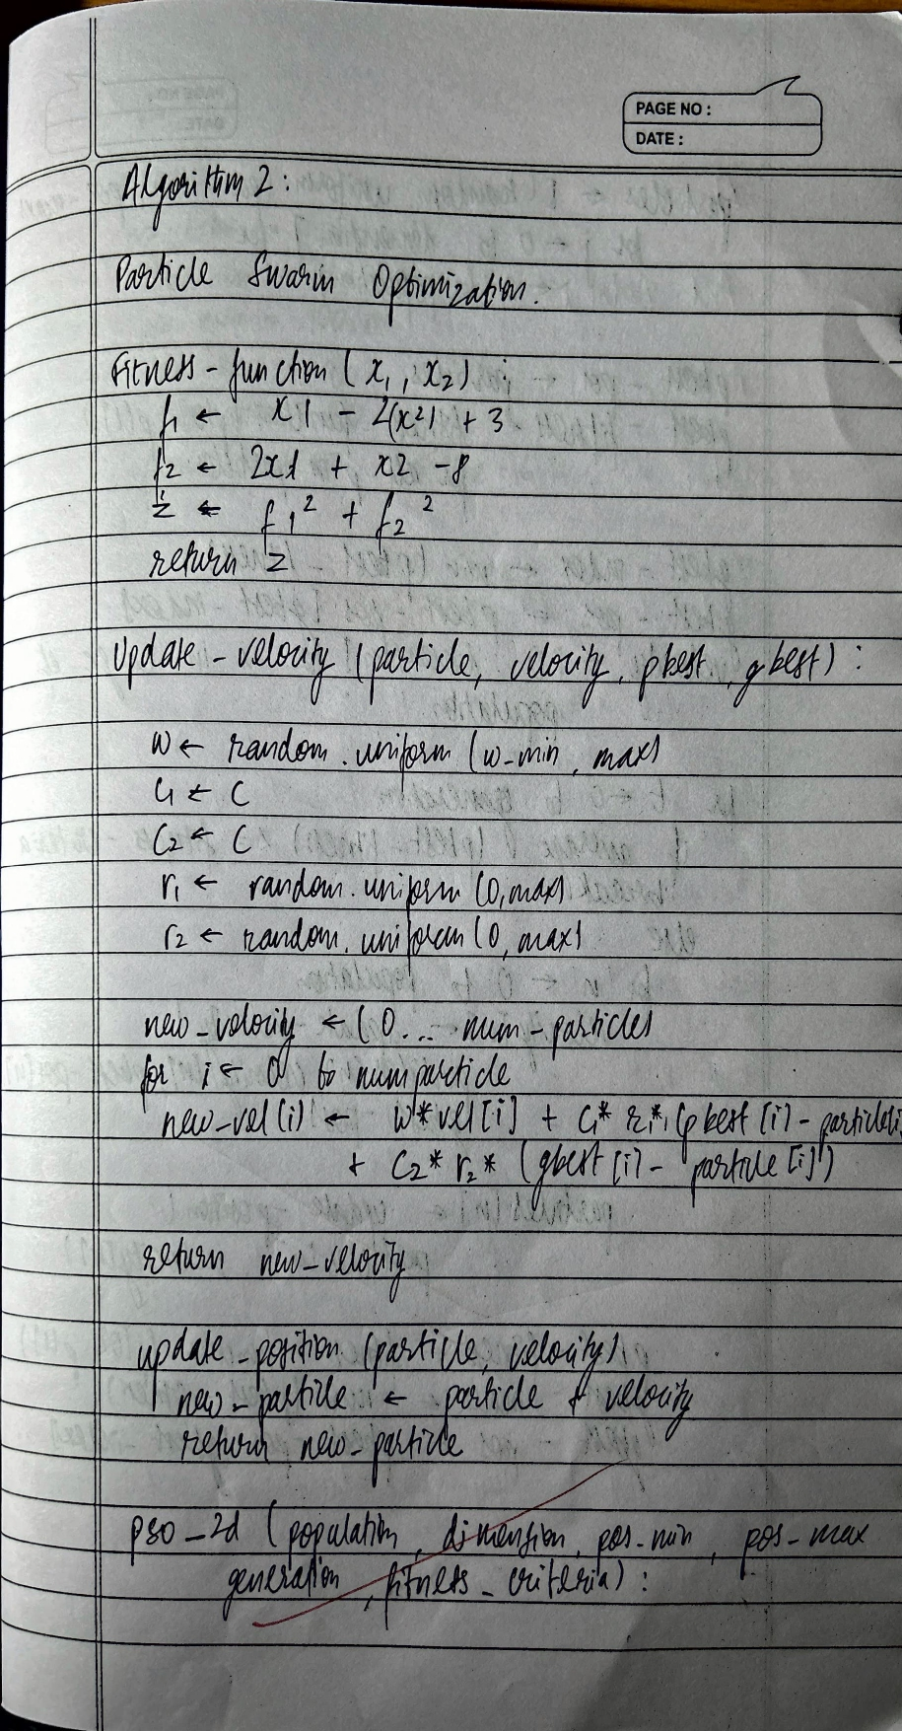

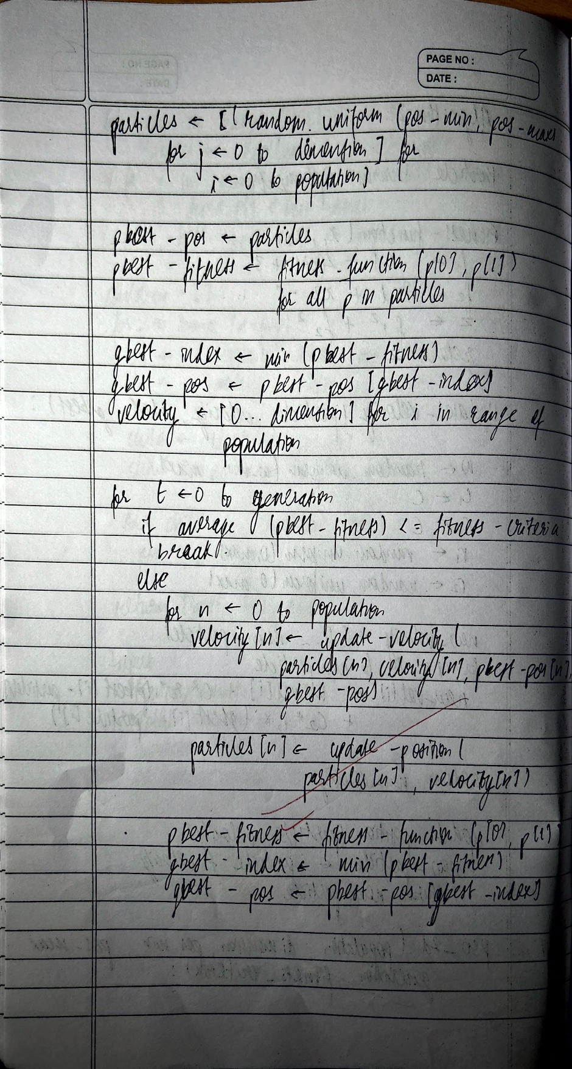

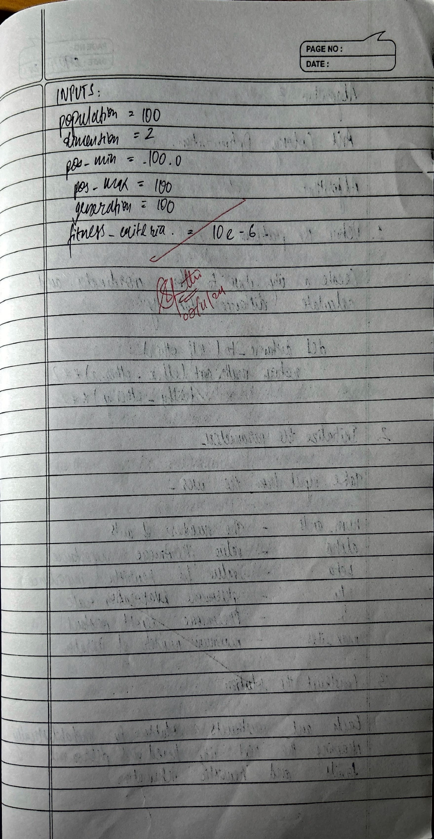

**CODE:**

import numpy as np

# Objective function (Example: Rastrigin function)

def objective_function(position):

return sum([x**2 - 10 * np.cos(2 * np.pi * x) + 10 for x in position])

# Particle Swarm Optimization

class Particle:

def __init__(self, dimensions):

self.position = np.random.uniform(-10, 10, dimensions) # Initialize position

self.velocity = np.random.uniform(-1, 1, dimensions) # Initialize velocity

self.best_position = self.position.copy() # Personal best position

self.best_score = float('inf') # Best score for personal best

def update_velocity(self, global_best_position, inertia, cognitive_const, social_const):

r1, r2 = np.random.rand(), np.random.rand()

cognitive = cognitive_const * r1 * (self.best_position - self.position)

social = social_const * r2 * (global_best_position - self.position)

self.velocity = inertia * self.velocity + cognitive + social

def update_position(self):

self.position += self.velocity

# PSO Algorithm

def particle_swarm_optimization(objective_func, dimensions, num_particles, max_iter):

inertia = 0.5 # Inertia weight

cognitive_const = 1.5 # Cognitive constant

social_const = 1.5 # Social constant

# Initialize particles

swarm = [Particle(dimensions) for _ in range(num_particles)]

global_best_position = np.random.uniform(-10, 10, dimensions)

global_best_score = float('inf')

for iteration in range(max_iter):

for particle in swarm:

# Evaluate fitness

fitness = objective_func(particle.position)

# Update personal best

if fitness < particle.best_score:

particle.best_score = fitness

particle.best_position = particle.position.copy()

# Update global best

if fitness < global_best_score:

global_best_score = fitness

global_best_position = particle.position.copy()

# Update velocity and position for each particle

for particle in swarm:

particle.update_velocity(global_best_position, inertia, cognitive_const, social_const)

particle.update_position()

print(f"Iteration {iteration+1}/{max_iter}, Global Best Score: {global_best_score}")

return global_best_position, global_best_score

# Example usage

best_position, best_score = particle_swarm_optimization(objective_function, dimensions=2, num_particles=30, max_iter=100)

print("Best Position:", best_position) print("Best Score:", best_score)

**Program 3**

**Ant Colony Optimization for the Traveling Salesman Problem**

Implement the ACO algorithm using Python to solve the TSP, where the objective is to find the shortest possible route that visits a list of cities and returns to the origin city.

Algorithm:

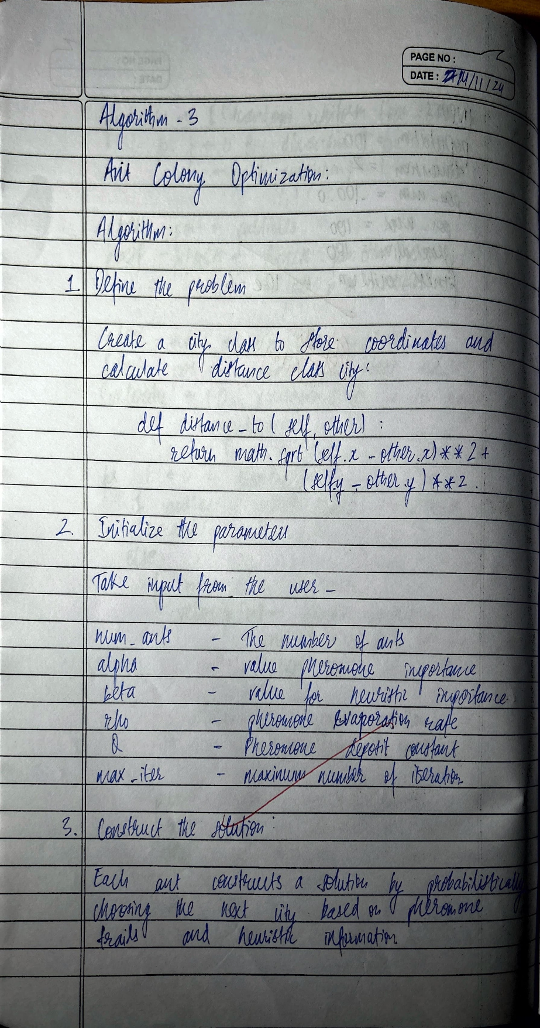

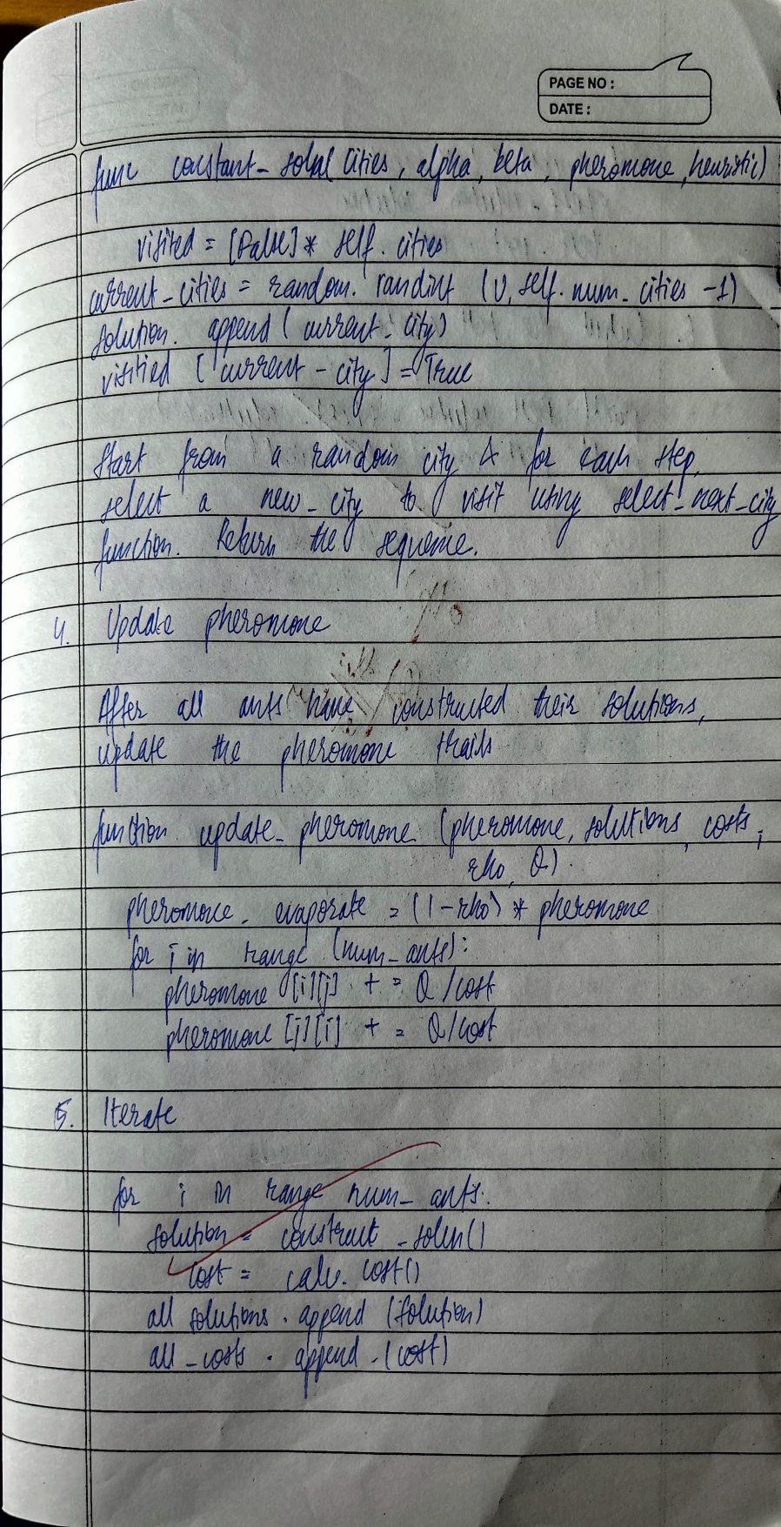

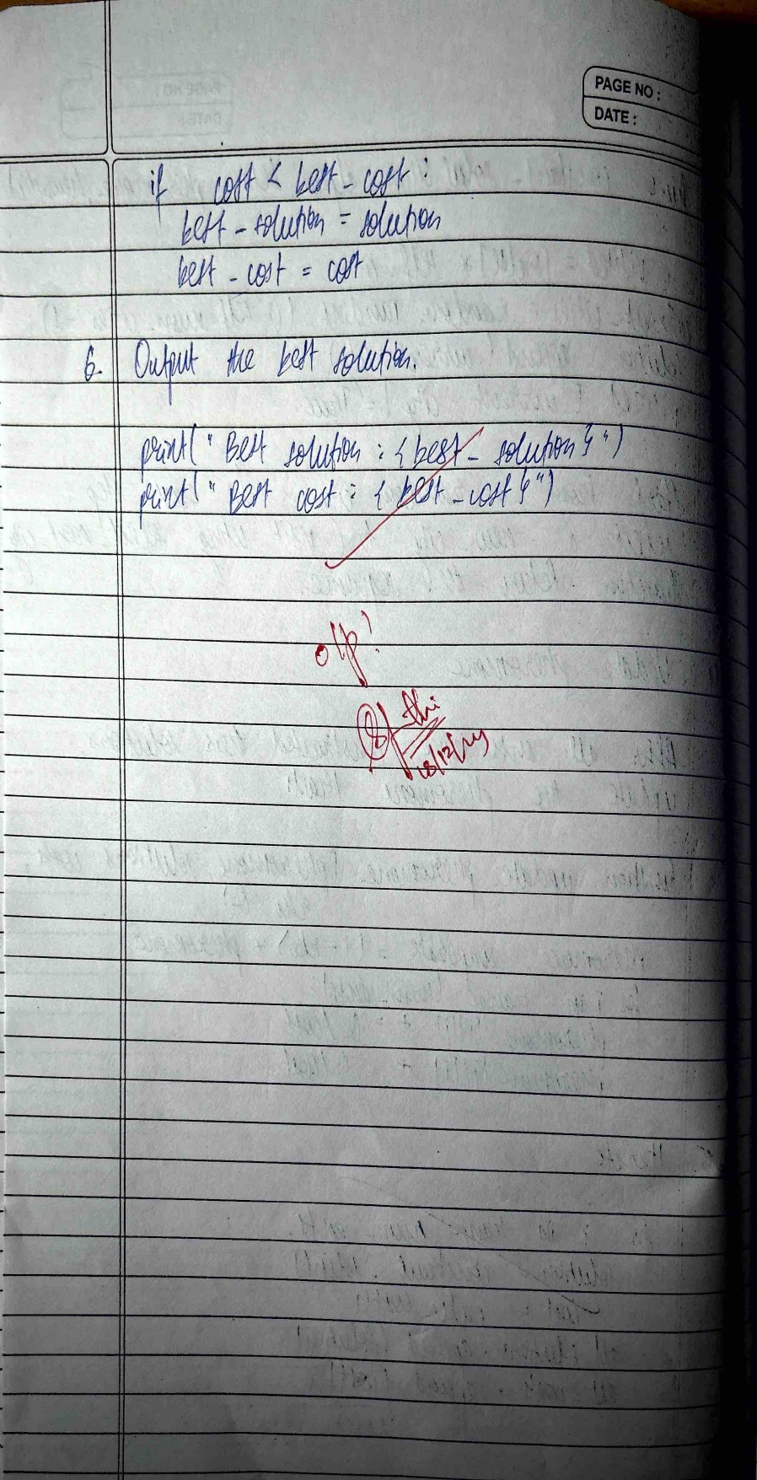

**CODE**:

import numpy as np

import random

class AntColony:

def __init__(self, distance_matrix, n_ants, n_iterations, decay, alpha=1, beta=1):

self.distance_matrix = distance_matrix

self.pheromone = np.ones(distance_matrix.shape) / len(distance_matrix)

self.n_ants = n_ants

self.n_iterations = n_iterations

self.decay = decay

self.alpha = alpha # Pheromone importance

self.beta = beta # Distance importance

self.all_indices = range(len(distance_matrix))

def run(self):

shortest_path = None

all_time_shortest_path = ("path", np.inf)

for _ in range(self.n_iterations):

all_paths = self.generate_all_paths()

self.update_pheromones(all_paths)

shortest_path = min(all_paths, key=lambda x: x[1])

if shortest_path[1] < all_time_shortest_path[1]:

all_time_shortest_path = shortest_path

return all_time_shortest_path

def generate_all_paths(self):

all_paths = []

for _ in range(self.n_ants):

path = self.generate_path(0) # Start from city 0

path_dist = self.calculate_path_distance(path)

all_paths.append((path, path_dist))

return all_paths

def generate_path(self, start):

path = [start]

visited = set(path)

while len(visited) < len(self.distance_matrix):

move = self.select_next_city(path[-1], visited)

path.append(move)

visited.add(move)

path.append(start) # Return to starting city

return path

def select_next_city(self, current_city, visited):

pheromone = np.copy(self.pheromone[current_city])

pheromone[list(visited)] = 0 # Avoid visiting already visited cities

probabilities = pheromone ** self.alpha * ((1 / self.distance_matrix[current_city]) ** self.beta)

probabilities /= probabilities.sum() # Normalize probabilities

next_city = np.random.choice(self.all_indices, p=probabilities)

return next_city

def calculate_path_distance(self, path):

total_dist = 0

for i in range(len(path) - 1):

total_dist += self.distance_matrix[path[i]][path[i + 1]]

return total_dist

def update_pheromones(self, all_paths):

self.pheromone *= (1 - self.decay) # Pheromone evaporation

for path, dist in all_paths:

for i in range(len(path) - 1):

self.pheromone[path[i]][path[i + 1]] += 1 / dist # Update pheromone based on path quality

# Example: A 4-city TSP problem

if __name__ == "__main__":

distance_matrix = np.array([[np.inf, 12, 12, 15],

[12, np.inf, 13, 14],

[12, 13, np.inf, 11],

[15, 14, 11, np.inf]])

colony = AntColony(distance_matrix, n_ants=10, n_iterations=100, decay=0.1, alpha=1, beta=2)

best_path = colony.run()

print("Best path found:", best_path)

**Program 4**

**Cuckoo Search (CS)**

Algorithm:

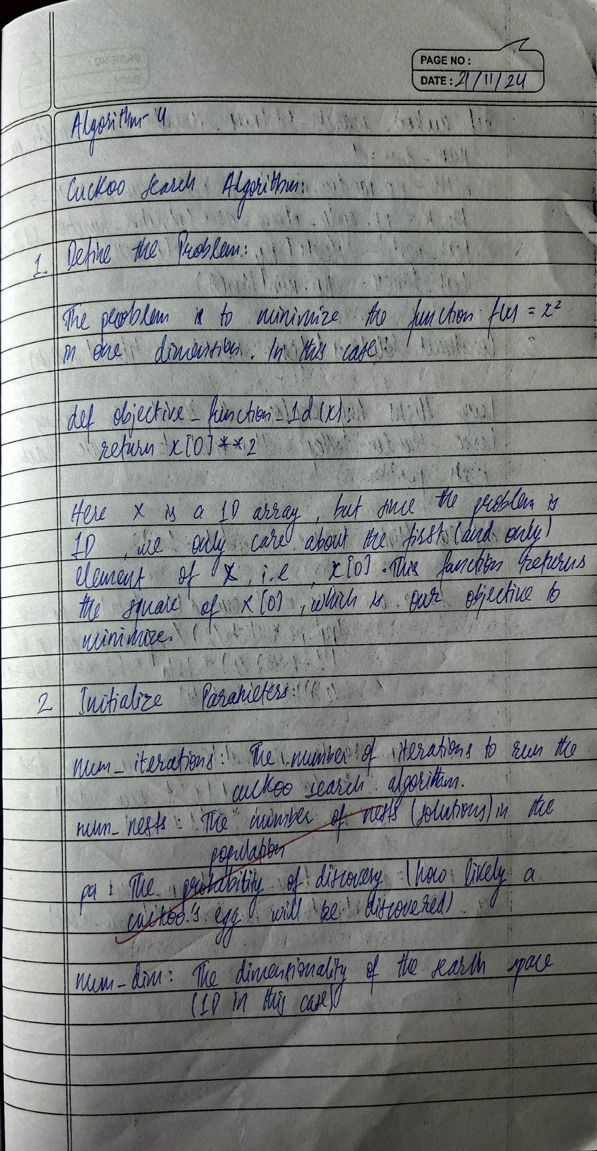

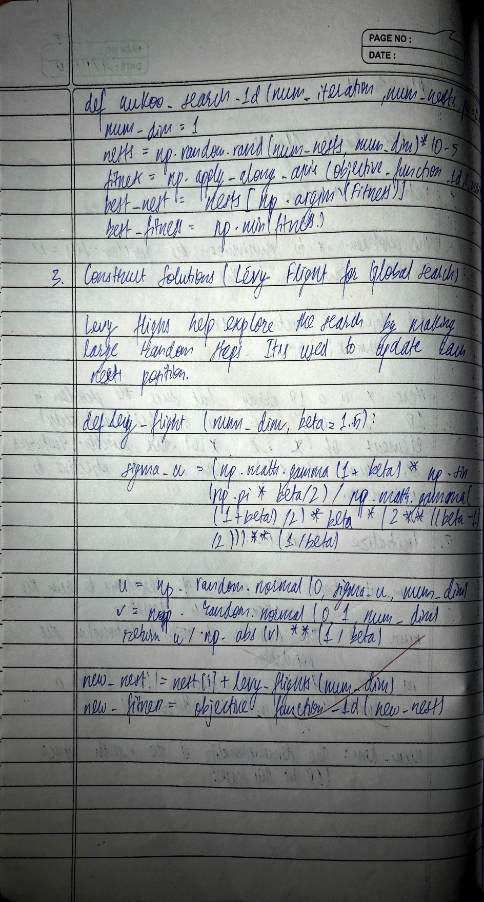

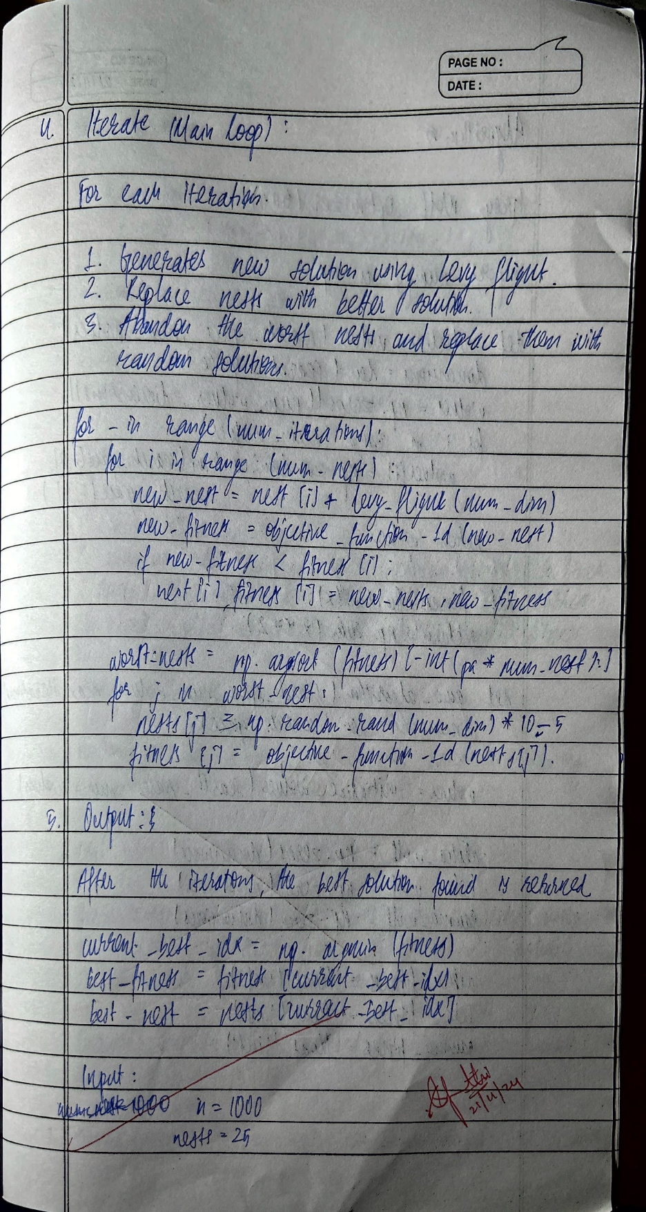

**CODE**:

import numpy as np

# Objective function (example: Sphere function)

def objective_function(x):

return np.sum(x ** 2)

# Levy flight implementation

def levy_flight(Lambda, dim, alpha=1.0):

u = np.random.normal(0, 1, size=dim)

v = np.random.normal(0, 1, size=dim)

step = alpha * (u / (np.abs(v) ** (1 / Lambda))) # Lévy step

return step

# Cuckoo Search Algorithm

def cuckoo_search(n, max_generations, pa, lower_bound, upper_bound, dim):

# Step 1: Initialize nests randomly

nests = np.random.uniform(lower_bound, upper_bound, size=(n, dim))

fitness = np.array([objective_function(nest) for nest in nests])

best_nest = nests[np.argmin(fitness)]

best_fitness = np.min(fitness)

# Iterative optimization

for t in range(max_generations):

# Rule 1: Generate new solutions via Lévy flight

for i in range(n):

new_nest = nests[i] + levy_flight(1.5, dim)

new_nest = np.clip(new_nest, lower_bound, upper_bound)

new_fitness = objective_function(new_nest)

# Rule 2: Replace nests if better

if new_fitness < fitness[i]:

nests[i] = new_nest

fitness[i] = new_fitness

# Update global best

if new_fitness < best_fitness:

best_nest = new_nest

best_fitness = new_fitness

# Rule 3: Abandon some nests and create new random ones

abandon = np.random.rand(n) < pa

nests[abandon] = np.random.uniform(lower_bound, upper_bound, size=(np.sum(abandon), dim))

fitness[abandon] = np.array([objective_function(nest) for nest in nests[abandon]])

return best_nest, best_fitness

# Parameters

n = 25 # Number of nests

dim = 5 # Dimensionality of the problem

max_generations = 100 # Max iterations

pa = 0.25 # Abandonment probability

lower_bound = -10 # Lower bound of the search space

upper_bound = 10 # Upper bound of the search space

# Run Cuckoo Search

best_solution, best_value = cuckoo_search(n, max_generations, pa, lower_bound, upper_bound, dim)

print("Best solution found:", best_solution)

print("Best objective value:", best_value)

**Program 5**

**Grey Wolf Optimizer (GWO):**

Algorithm:

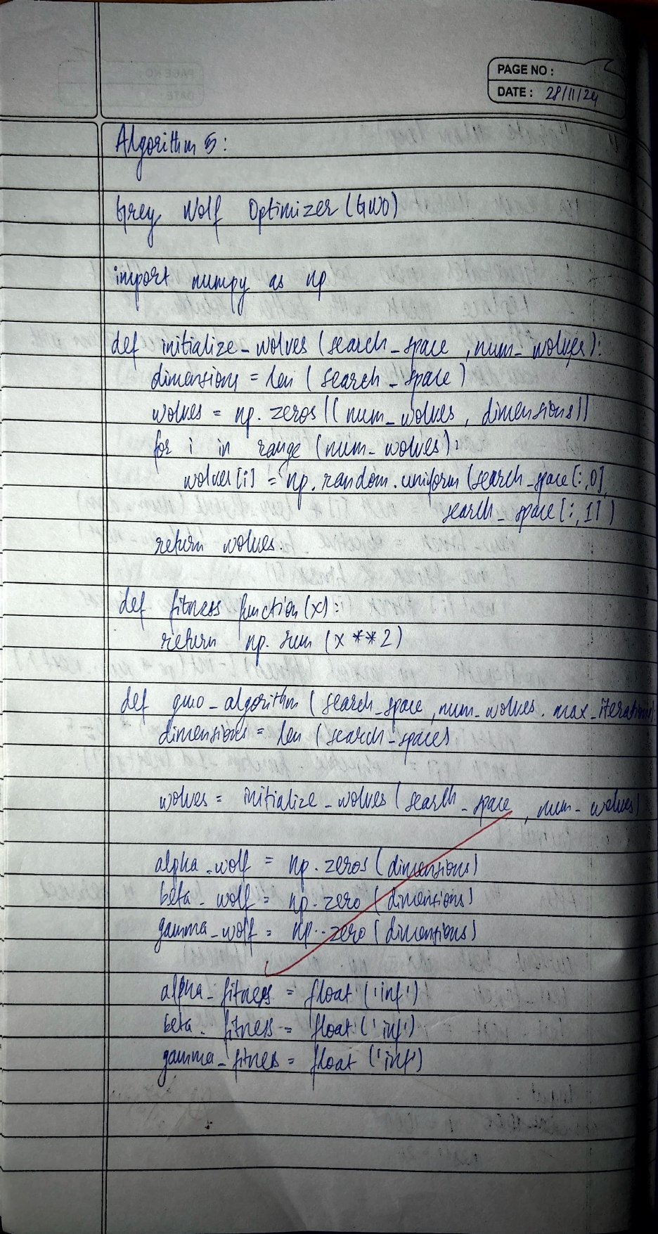

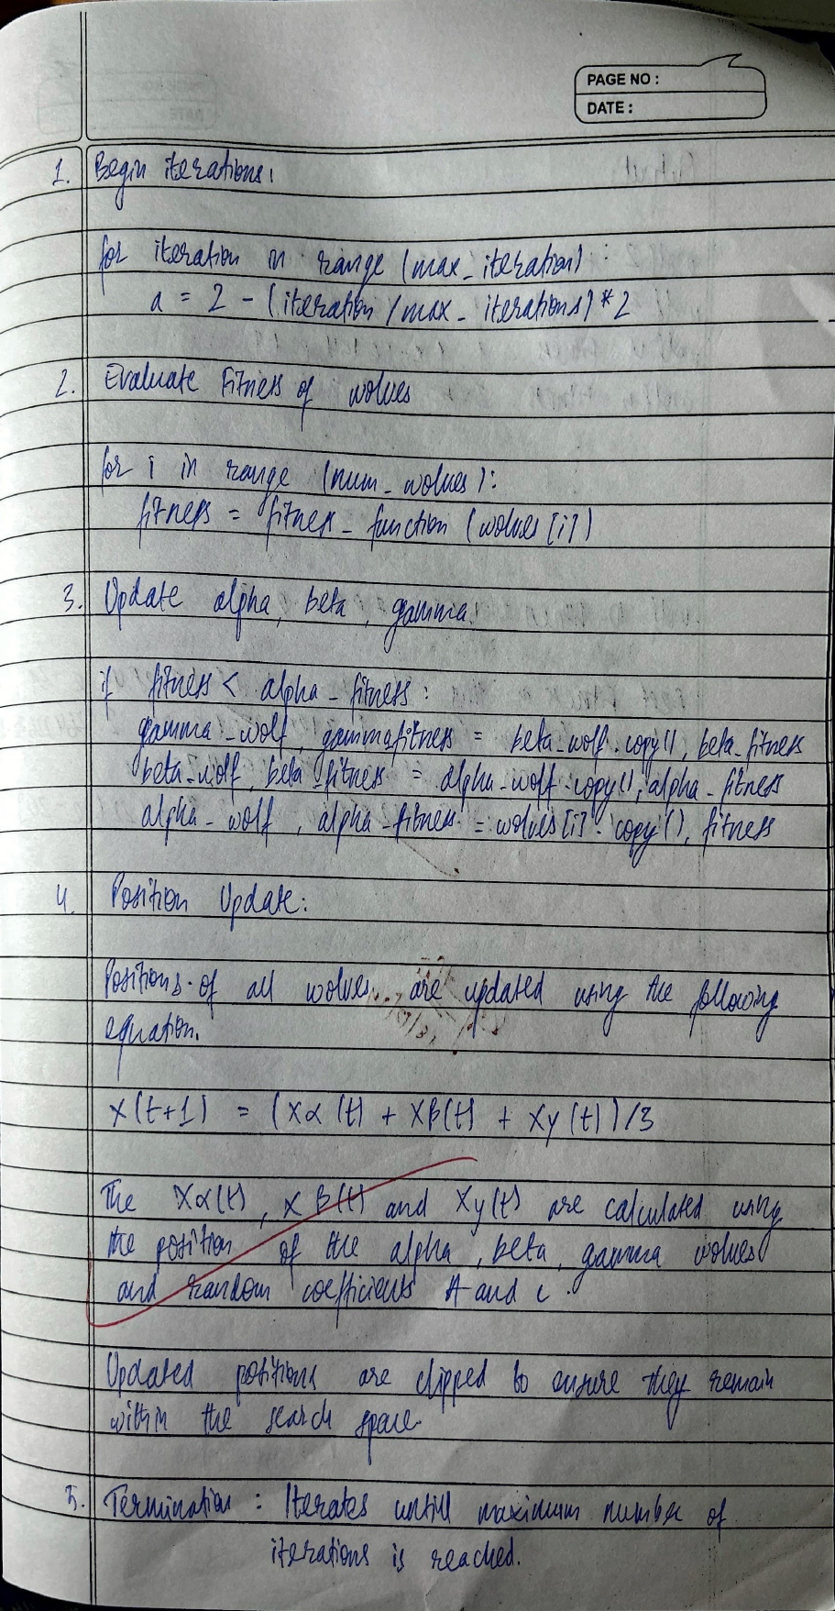

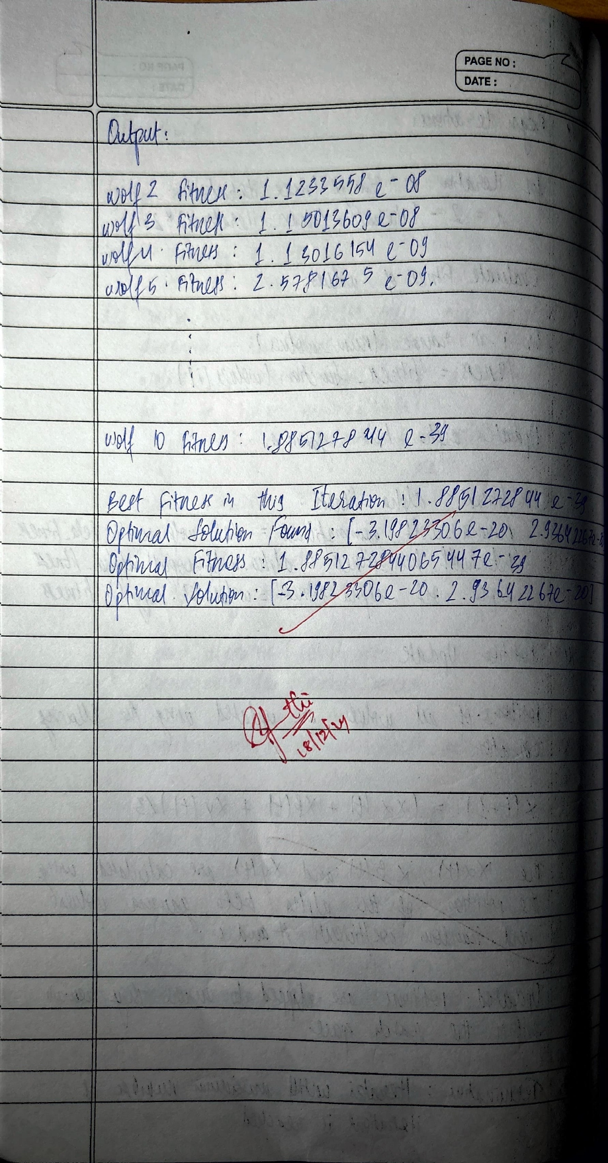

**CODE**:

import numpy as np

# Objective function (e.g., Sphere function)

def objective_function(position):

return sum(x**2 for x in position)

# Grey Wolf Optimizer

def grey_wolf_optimizer(obj_function, dim, pop_size, max_iter, bounds=(-10, 10)):

a = 2 # Coefficient, decreases linearly from 2 to 0

alpha_position = np.zeros(dim)

alpha_score = float('inf') # Best fitness (alpha)

beta_position = np.zeros(dim)

beta_score = float('inf') # Second-best fitness (beta)

delta_position = np.zeros(dim)

delta_score = float('inf') # Third-best fitness (delta)

# Initialize the positions of the wolves

wolves = np.random.uniform(bounds[0], bounds[1], (pop_size, dim))

for iteration in range(max_iter):

for i, wolf in enumerate(wolves):

fitness = obj_function(wolf)

# Update alpha, beta, and delta

if fitness < alpha_score:

delta_position = beta_position.copy()

delta_score = beta_score

beta_position = alpha_position.copy()

beta_score = alpha_score

alpha_position = wolf.copy()

alpha_score = fitness

elif fitness < beta_score:

delta_position = beta_position.copy()

delta_score = beta_score

beta_position = wolf.copy()

beta_score = fitness

elif fitness < delta_score:

delta_position = wolf.copy()

delta_score = fitness

# Update positions

for i, wolf in enumerate(wolves):

r1, r2 = np.random.rand(dim), np.random.rand(dim)

A1 = 2 * a * r1 - a

C1 = 2 * r2

D_alpha = abs(C1 * alpha_position - wolf)

X1 = alpha_position - A1 * D_alpha

r1, r2 = np.random.rand(dim), np.random.rand(dim)

A2 = 2 * a * r1 - a

C2 = 2 * r2

D_beta = abs(C2 * beta_position - wolf)

X2 = beta_position - A2 * D_beta

r1, r2 = np.random.rand(dim), np.random.rand(dim)

A3 = 2 * a * r1 - a

C3 = 2 * r2

D_delta = abs(C3 * delta_position - wolf)

X3 = delta_position - A3 * D_delta

wolves[i] = (X1 + X2 + X3) / 3

# Linearly decrease a

a -= 2 / max_iter

print(f"Iteration {iteration+1}/{max_iter}, Alpha Score: {alpha_score}")

return alpha_position, alpha_score

# Example usage

best_position, best_score = grey_wolf_optimizer(objective_function, dim=2, pop_size=30, max_iter=100)

print("Best Position:", best_position)

print("Best Score:", best_score)

**Program 6**

**Parallel Cellular Algorithms and Programs:**

Algorithm:

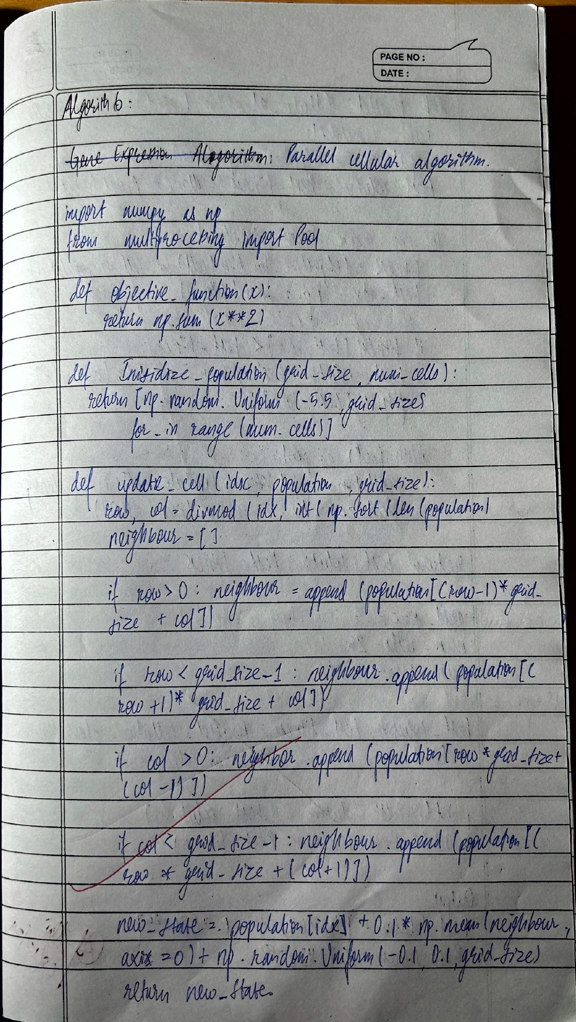

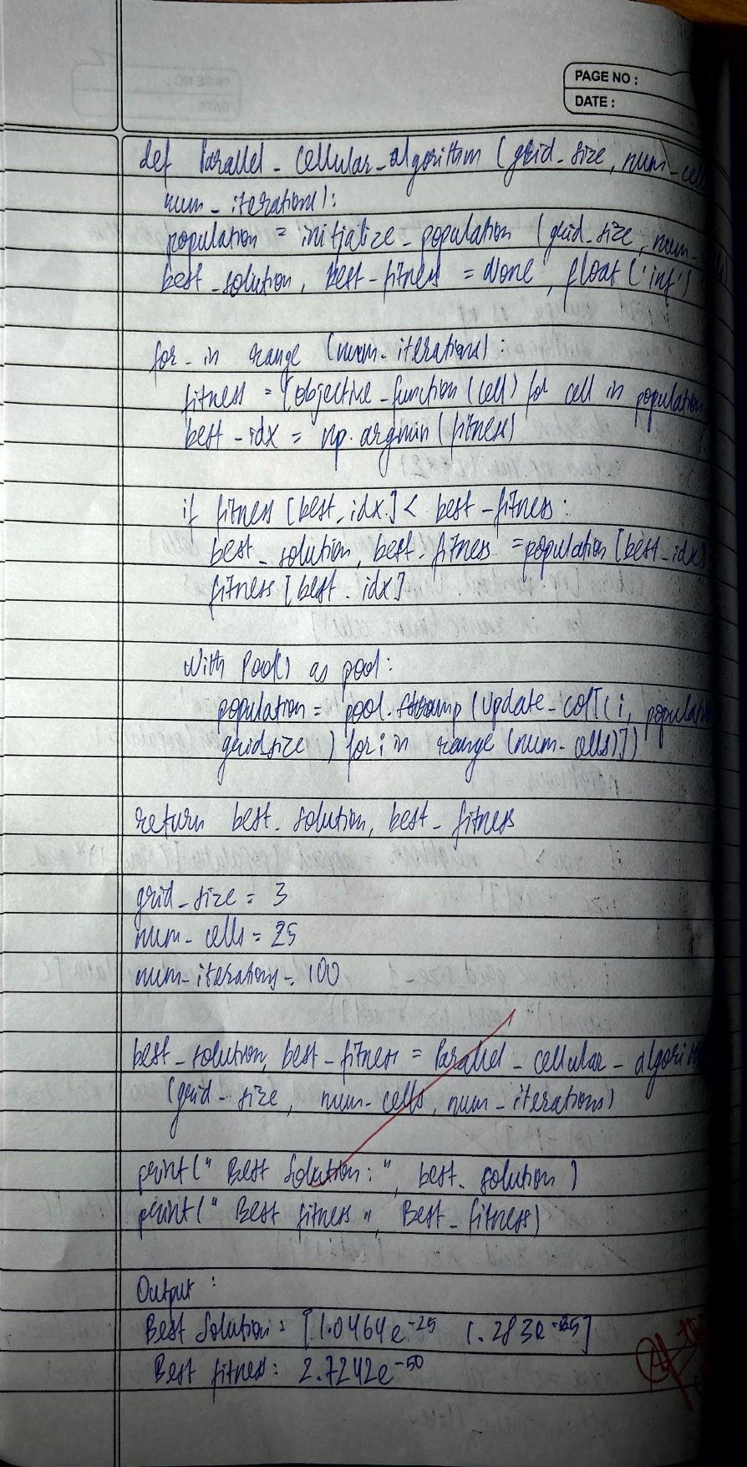

**CODE**:

import numpy as np

# Define the objective function

def objective_function(x):

return x**2 - 4*x + 4

# Initialize the grid

def initialize_grid(grid_size, search_range):

return np.random.uniform(search_range[0], search_range[1], (grid_size, grid_size))

# Compute fitness for the grid

def evaluate_fitness(grid, objective_function):

return objective_function(grid)

# Update the grid based on neighborhood average

def update_grid(grid):

new_grid = np.copy(grid)

for i in range(grid.shape[0]):

for j in range(grid.shape[1]):

# Get neighbors' values

neighbors = []

for di in [-1, 0, 1]:

for dj in [-1, 0, 1]:

ni, nj = i + di, j + dj

if 0 <= ni < grid.shape[0] and 0 <= nj < grid.shape[1]:

neighbors.append(grid[ni, nj])

# Update state to the average of neighbors

new_grid[i, j] = np.mean(neighbors)

return new_grid

# Main function to run the algorithm

def parallel_cellular_algorithm(grid_size, search_range, iterations):

grid = initialize_grid(grid_size, search_range) # Step 2: Initialize grid

for _ in range(iterations):

fitness = evaluate_fitness(grid, objective_function) # Step 3: Evaluate fitness

grid = update_grid(grid) # Step 4: Update states

# Find the best solution

best_value = grid[np.unravel_index(np.argmin(fitness), fitness.shape)]

return best_value, objective_function(best_value)

# Parameters

grid_size = 10 # 10x10 grid

search_range = (-10, 10) # Search range for cell values

iterations = 100 # Number of iterations

# Run the algorithm

best_value, best_fitness = parallel_cellular_algorithm(grid_size, search_range, iterations)

# Output the results

print(f"Best Value: {best_value}")

print(f"Best Fitness: {best_fitness}")

**Program 7**

**Optimization via Gene Expression Algorithms:**

Algorithm:

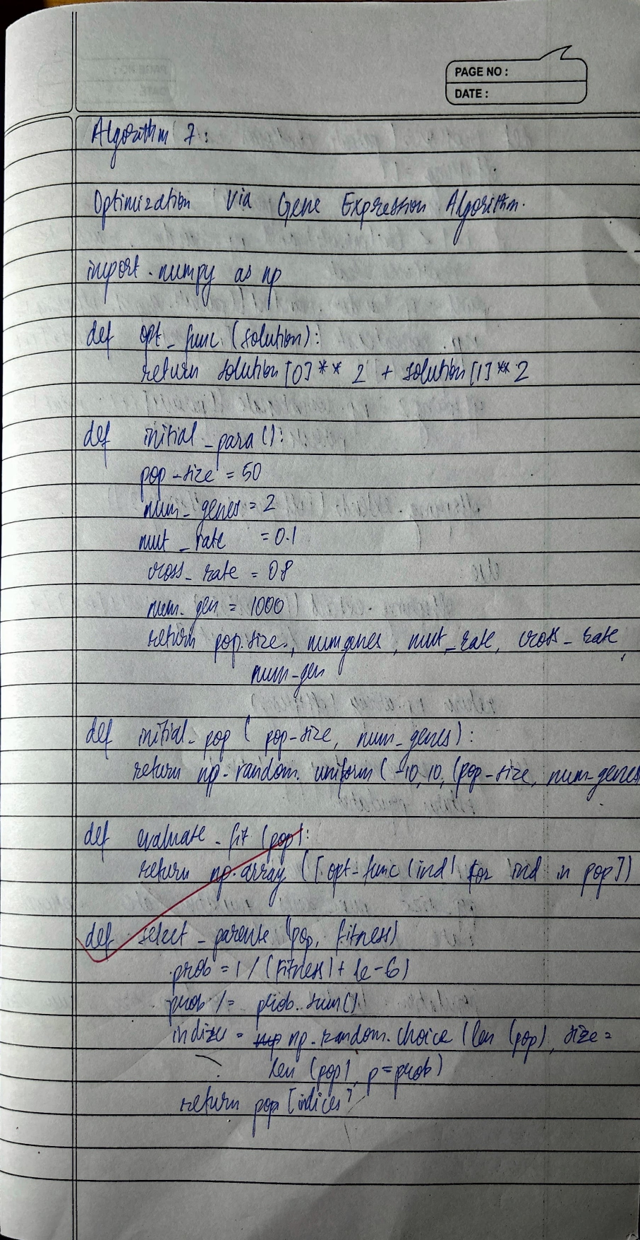

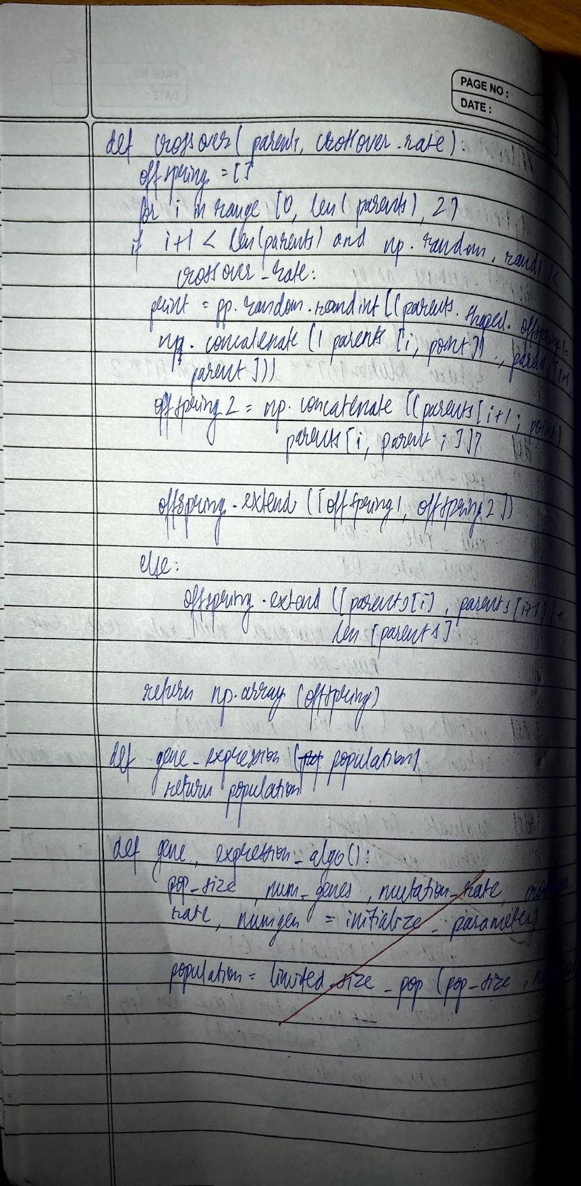

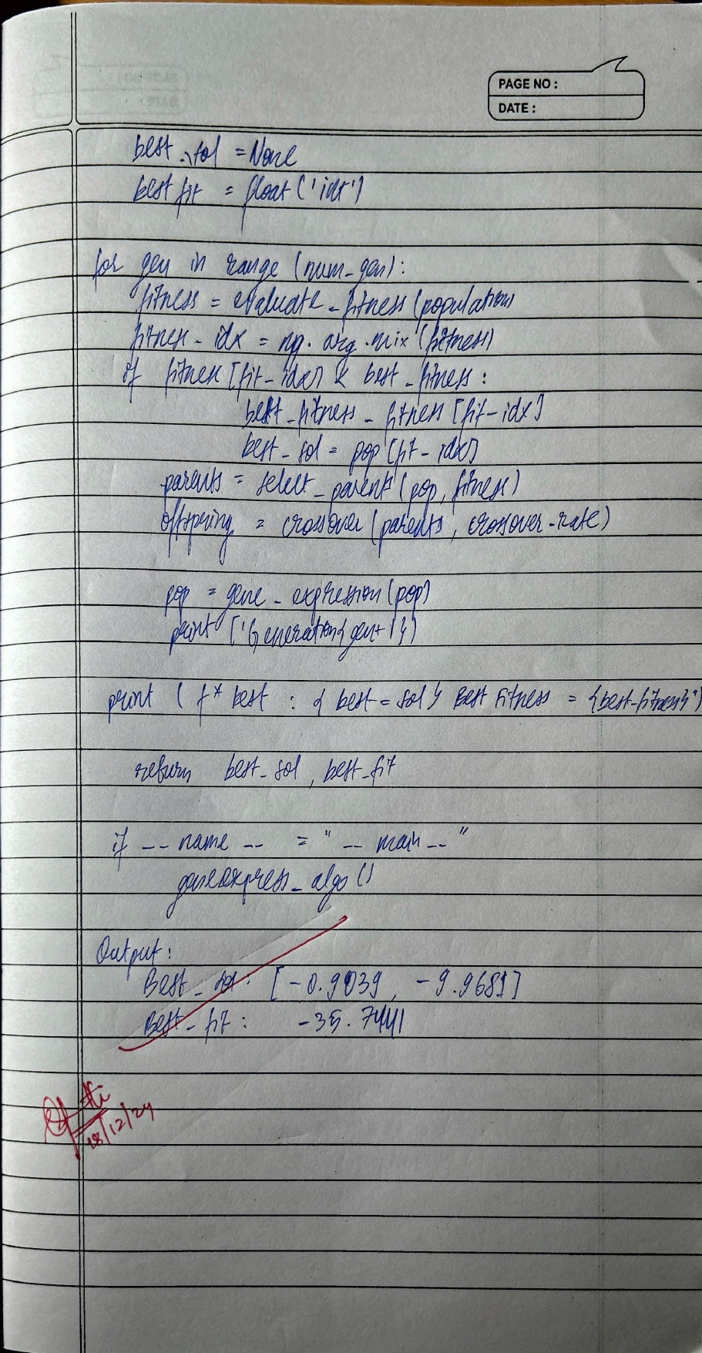

**CODE**:

import numpy as np

import random

# Define the Rastrigin function (objective function)

def rastrigin_function(x):

A = 10

n = len(x)

return A * n + sum([(xi ** 2 - A * np.cos(2 * np.pi * xi)) for xi in x])

# Initialize population

def initialize_population(pop_size, gene_length, search_range):

return [np.random.uniform(search_range[0], search_range[1], gene_length) for _ in range(pop_size)]

# Evaluate fitness

def evaluate_fitness(population):

return [rastrigin_function(ind) for ind in population]

# Selection (tournament selection)

def selection(population, fitness):

selected = []

for _ in range(len(population)):

i, j = random.sample(range(len(population)), 2)

selected.append(population[i] if fitness[i] < fitness[j] else population[j])

return selected

# Crossover (uniform crossover)

def crossover(parent1, parent2):

child = []

for p1, p2 in zip(parent1, parent2):

child.append(p1 if random.random() < 0.5 else p2)

return np.array(child)

# Mutation (random mutation)

def mutate(individual, mutation_rate, search_range):

for i in range(len(individual)):

if random.random() < mutation_rate:

individual[i] = random.uniform(search_range[0], search_range[1])

return individual

# Gene Expression Algorithm

def gene_expression_algorithm(pop_size, gene_length, generations, mutation_rate, search_range):

# Step 1: Initialize population

population = initialize_population(pop_size, gene_length, search_range)

for generation in range(generations):

# Step 2: Evaluate fitness

fitness = evaluate_fitness(population)

# Step 3: Selection

selected_population = selection(population, fitness)

# Step 4: Crossover and Mutation

next_population = []

for i in range(0, len(selected_population), 2):

if i + 1 < len(selected_population):

# Crossover

child1 = crossover(selected_population[i], selected_population[i + 1])

child2 = crossover(selected_population[i + 1], selected_population[i])

else:

child1 = selected_population[i]

child2 = selected_population[i]

# Mutation

next_population.append(mutate(child1, mutation_rate, search_range))

next_population.append(mutate(child2, mutation_rate, search_range))

population = next_population[:pop_size] # Maintain population size

# Final fitness evaluation

fitness = evaluate_fitness(population)

best_individual = population[np.argmin(fitness)]

return best_individual, rastrigin_function(best_individual)

# Parameters

pop_size = 50

gene_length = 10

generations = 100

mutation_rate = 0.1

search_range = (-5.12, 5.12) # Search range for Rastrigin function

# Run the algorithm

best_solution, best_fitness = gene_expression_algorithm(pop_size, gene_length, generations, mutation_rate, search_range)

print(f"Best Solution: {best_solution}")

print(f"Best Fitness: {best_fitness}")